**EXPERIMENT 3**

**AIM:** To configure a Virtual Private Cloud VPC & Troubleshoot a VPC

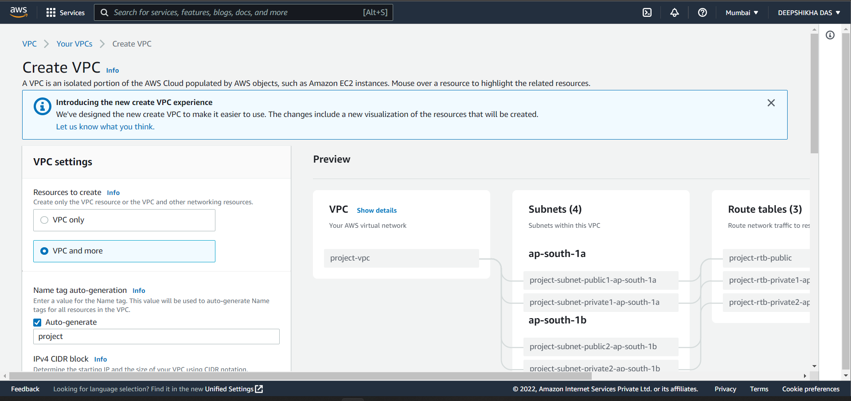

Search for VPC in the search bar and open the VPC dashboard page.

To create a new VPC, click “Create VPC” and go to the Create VPC page.

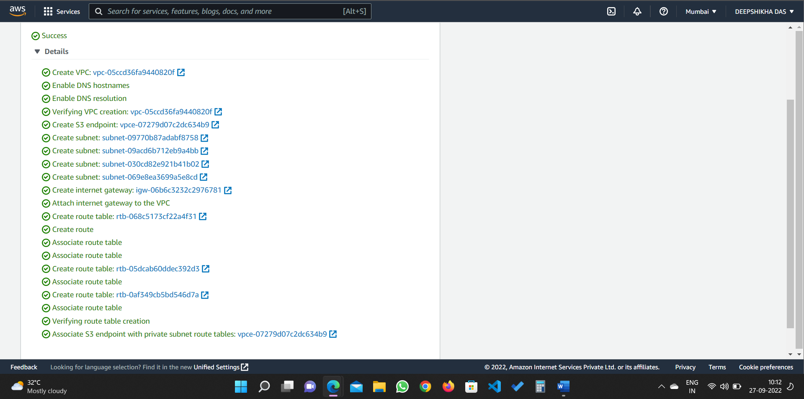

Select the following configurations with appropriate VPC name.

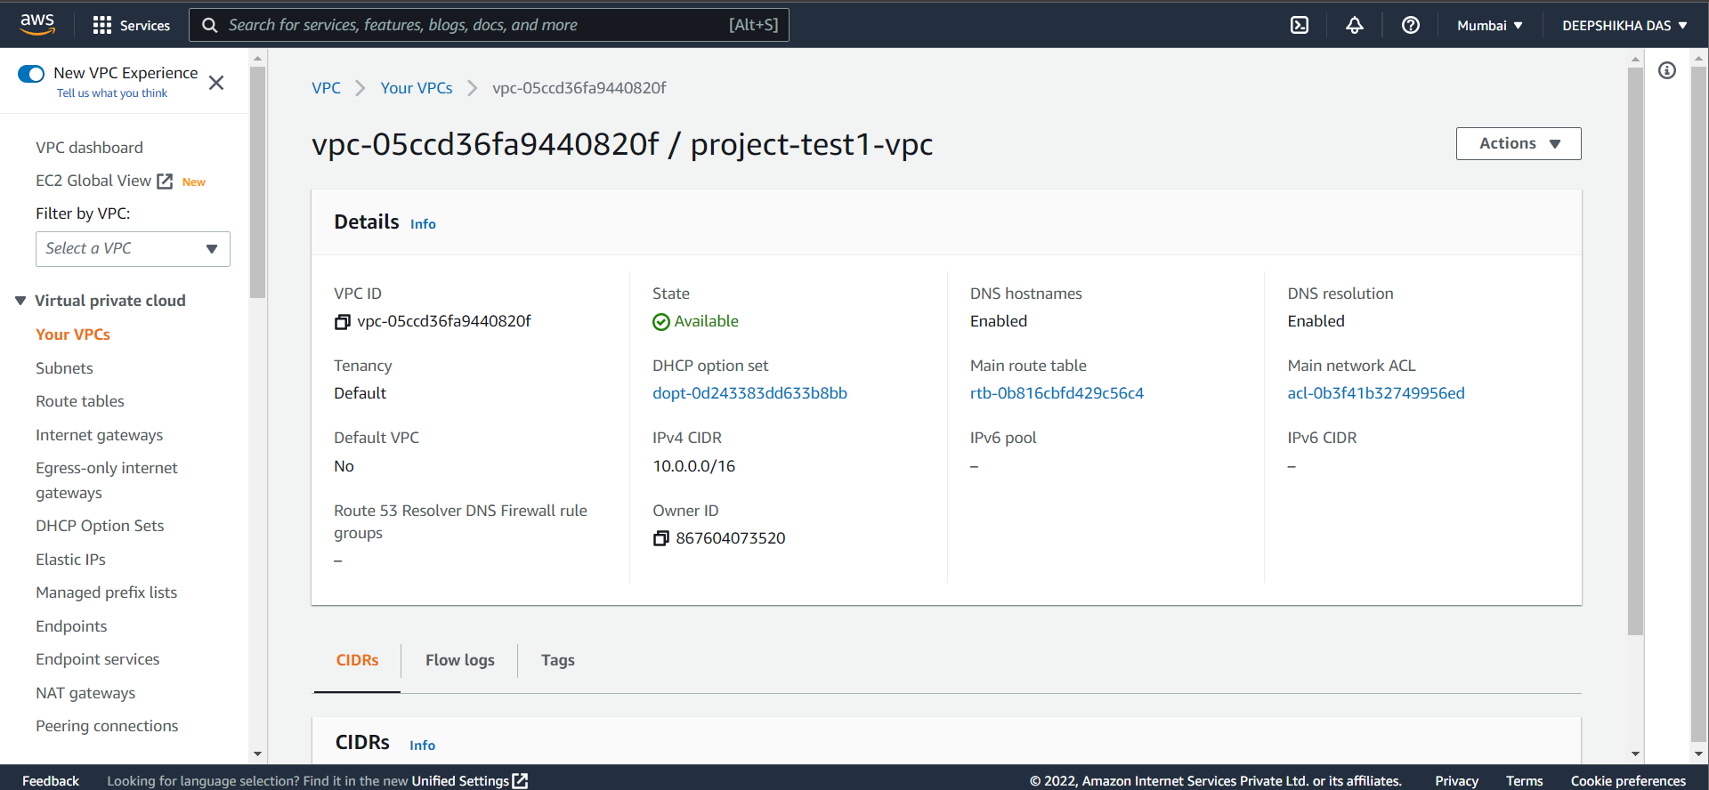

Click on “Create VPC” button and wait for your VPC to be created.

Click on “View VPC” to view your VPC details.

Click on “Subnets” in the left side menu to view subnets of your VPC.

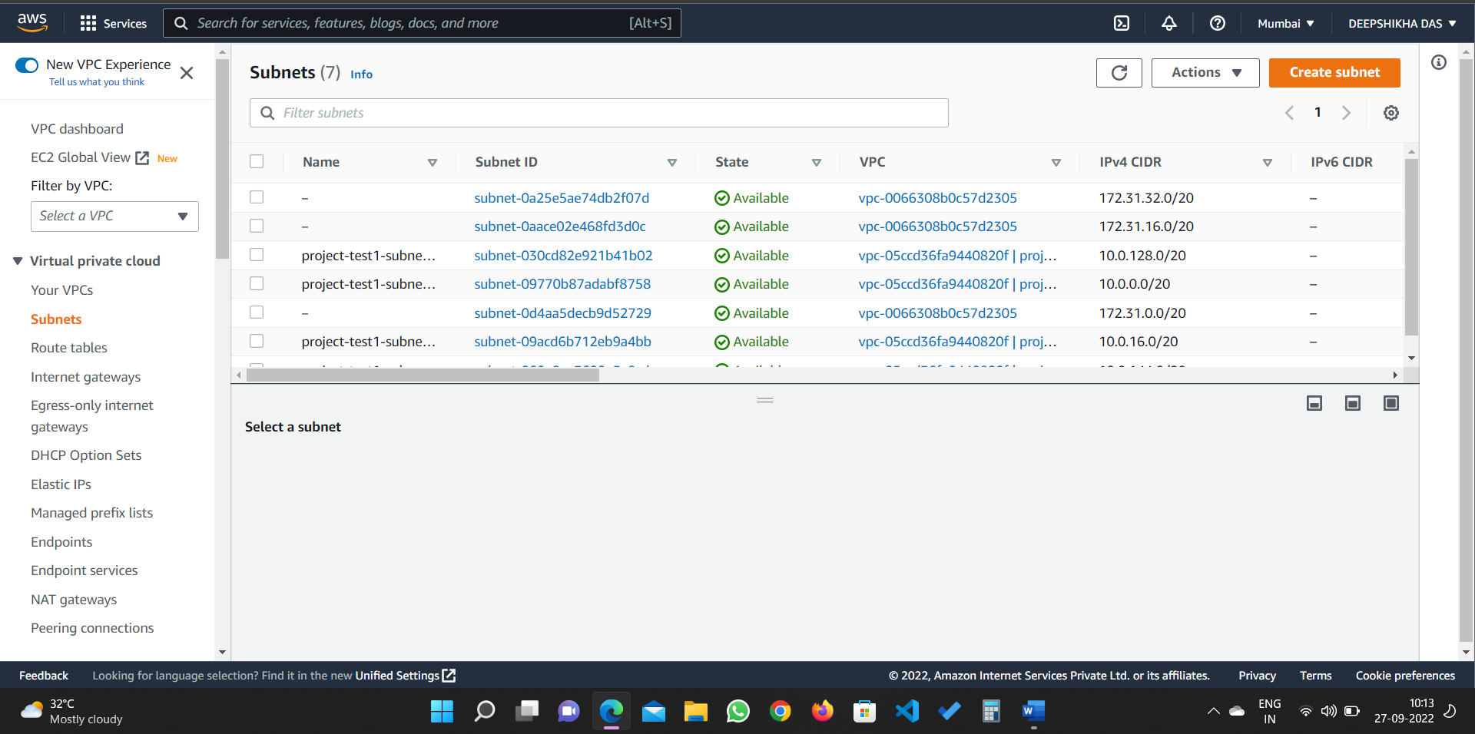

Click on “Route Tables” in the left side menu to view route tables of your VPC.

Click on “Network ACL’s” in the left side menu to view ACLs of your VPC.

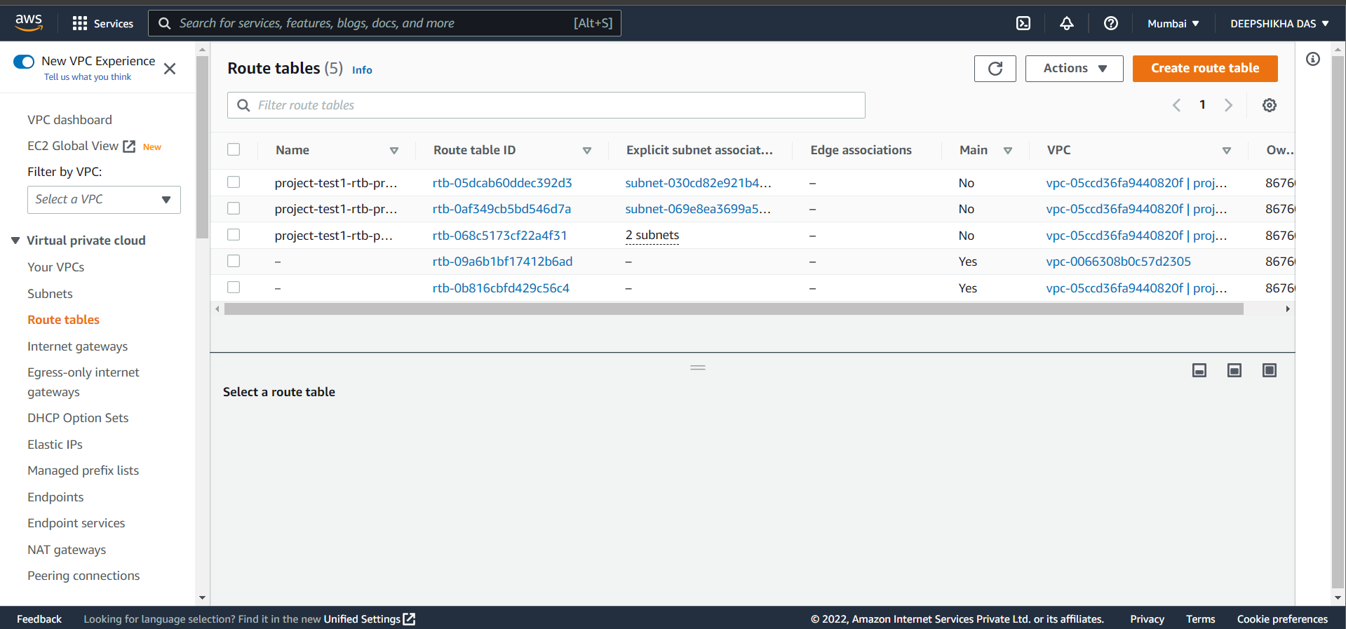

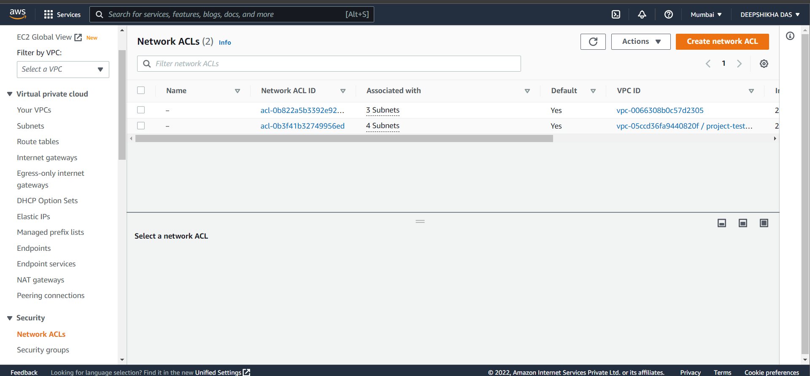

**RESULT:** A Virtual Private Cloud (VPC) was successfully created and troubleshooted.